Case Scenario

SparkCheck performs regular electrical equipment inspections on a contract basis for a wide range of organizations. It also undertakes emergency inspections as requested, often associated with power problems.

**‘As-is’ process:** The inspectors collect a printed works order list from the depot at the start

of the working day. They record information about their inspections in a manual folder. At the end of the day, they return to the office and enter the information collected into the company's inspection management system.

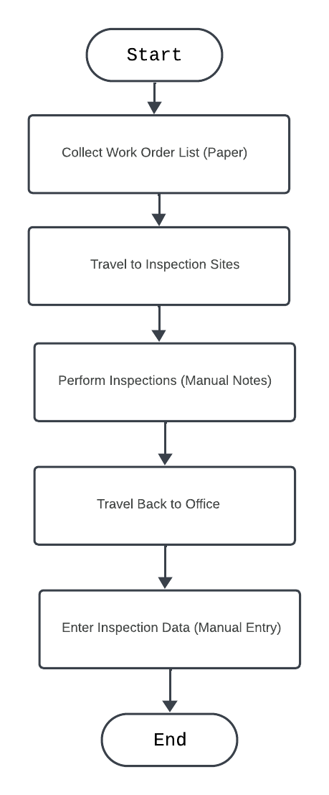

**‘To-be’ process:** The inspectors collect a printed work order list from the depot at the start

of the working day, but they will now enter collected information into a handheld data collection device. This device will provide standard fault codes and information about the type and location of equipment; it will also allow inspectors to capture data immediately and work remotely

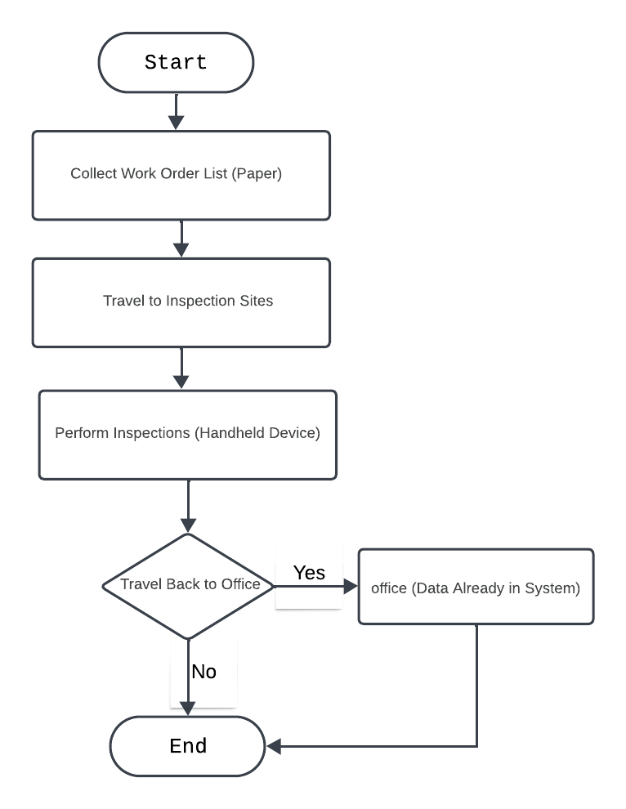

**How To-Be Process Improves Efficiency**

The To-Be process improves efficiency in several ways:

1. **Reduced Manual Data Entry:** Eliminates the need for inspectors to manually enter data into the system at the end of the day, saving significant time.
2. **Real-Time Data Capture:** Data is captured immediately after the inspection, reducing the risk of errors or missing information.
3. **Increased Accessibility:** Information can be accessed remotely, allowing for better communication and collaboration between inspectors and other departments.
4. **Improved Data Accuracy:** Standardized fault codes and equipment information minimize errors in data entry.
5. **Reduced Travel Time (Optional):** Since data entry can happen on-site, inspectors may not need to return to the office every day, potentially reducing travel time.